DS-A3 | Regression Baseline and Diagnostics
Complete work in GIT-HUB: https://github.com/alldeolove10-SJ/2026A8000531008_DEONISIO-YOHANES-WILFRIDUS-HORNAY_DS-A3-Regression-Baseline-and-Diagnostics
Dataset: scikit-learn Diabetes dataset (442 observations, 10 predictors) https://scikit-learn.org/stable/modules/generated/sklearn.datasets.load_diabetes?
Fixed split: 80/20, random_state=42
Local CSV SHA-256: f16718c1e6602b419193b9a023dbe278ae7f85ff343158813d7040a9f7512dec

Dataset and method
The scikit-learn Diabetes dataset contains 442 observations and 10 predictors. The local CSV was frozen and identified by a SHA-256 hash. A fixed 80/20 train–test split used random_state=42; the test set was not used for model selection. A training-mean baseline, ordinary linear regression, and Ridge regression were compared. Ridge’s alpha was selected by five-fold cross-validation using training data only.
Main result: Ridge achieved test RMSE 53.777 and R² 0.454, only a marginal improvement over linear regression (RMSE 53.853, R² 0.453). Both regression models outperformed the naive-mean baseline. The model remains a baseline rather than a deployment-ready system because diagnostics and slice analysis show issues that need further investigation.
Model | MAE | RMSE | R²
Naive mean | 64.006 | 73.222 | ‒0.012
Linear regression | 42.794 | 53.853 | 0.453
Ridge (α=1) | 42.812 | 53.777 | 0.454
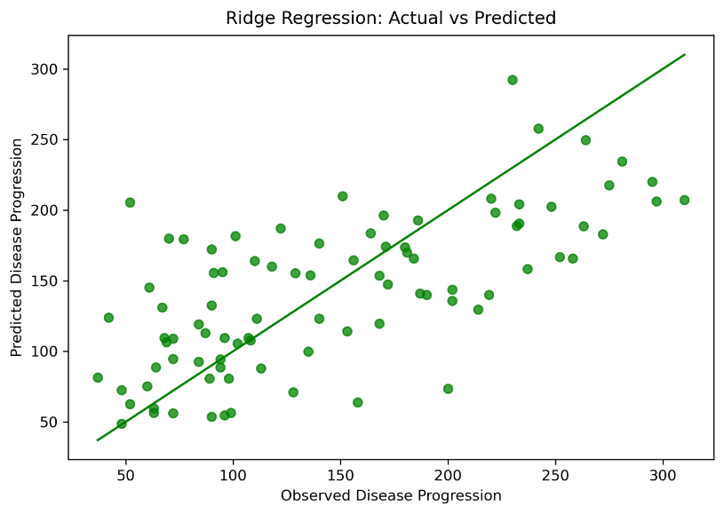
Figure 1. Ridge regression: actual versus predicted
Predictions rise with observed disease progression, but the points are widely scattered around the reference line. The model captures a useful trend while leaving substantial individual prediction error.
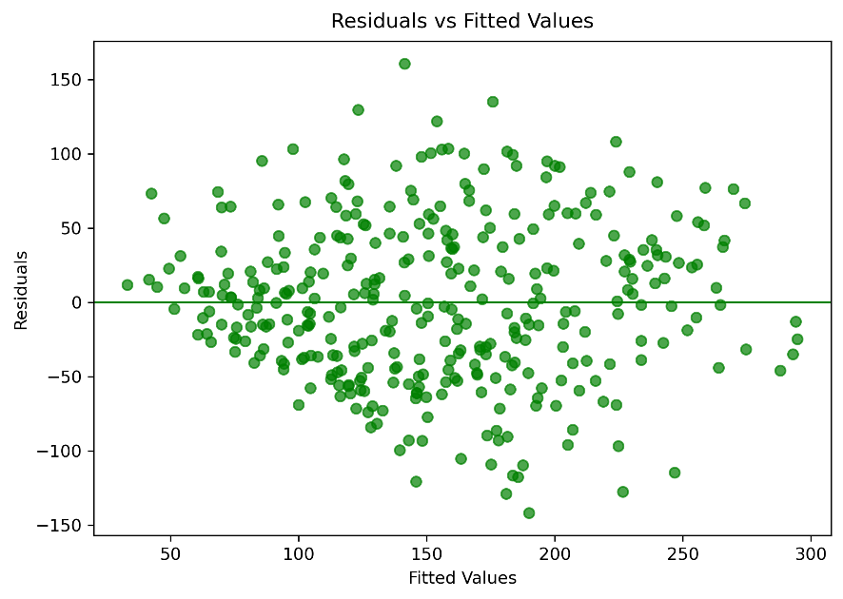
Figure 2. Residuals versus fitted values
Residuals fall on both sides of zero, but their spread varies across fitted values and several large errors remain. This supports checking non-constant variance and investigating large residuals.

Diagnostic Evidence
Residual and influence checks help assess model assumptions and identify observations that may affect the fitted relationship. They complement, but do not replace, held-out performance metrics.
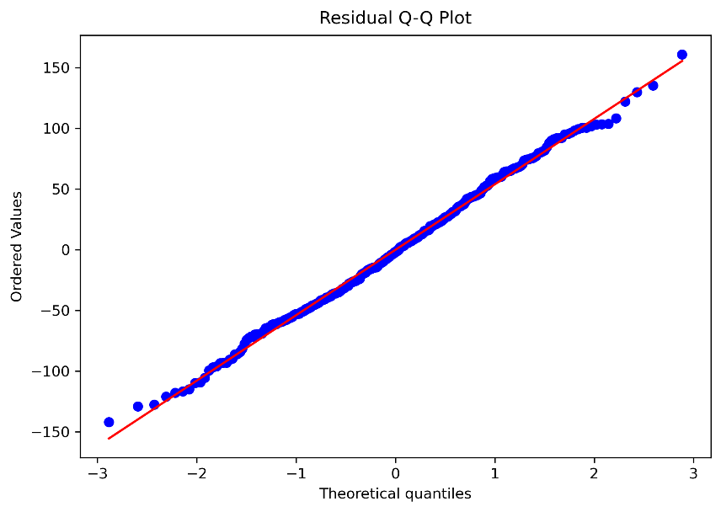
Figure 3. Residual Q–Q plot
Most points follow the reference line reasonably closely, suggesting approximate normality. Deviations at the tails show that the most extreme residuals do not follow the line perfectly.
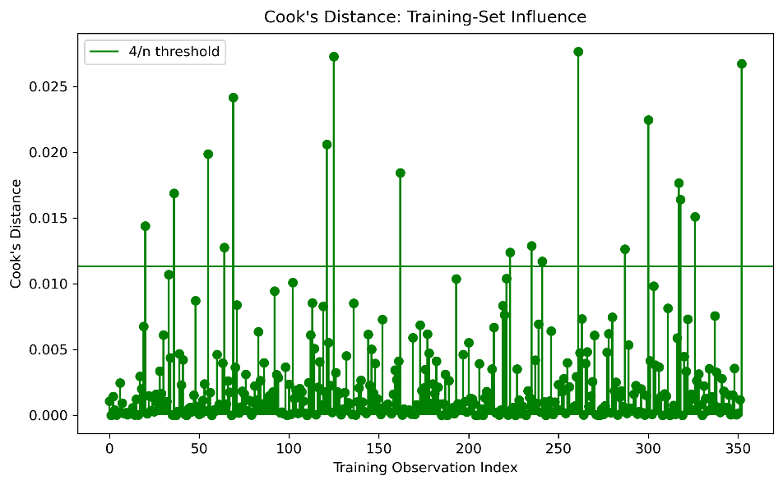
Figure 4. Cook’s distance
Eighteen observations exceed the 4/n screening threshold; the maximum Cook’s distance is 0.0277. Review these cases, but treat the threshold as a screening guide rather than an automatic reason for removal.

Generalization and Subgroup Performance
Learning curves show how performance changes with training-set size, while slice analysis checks whether errors are similar across a meaningful subgroup.
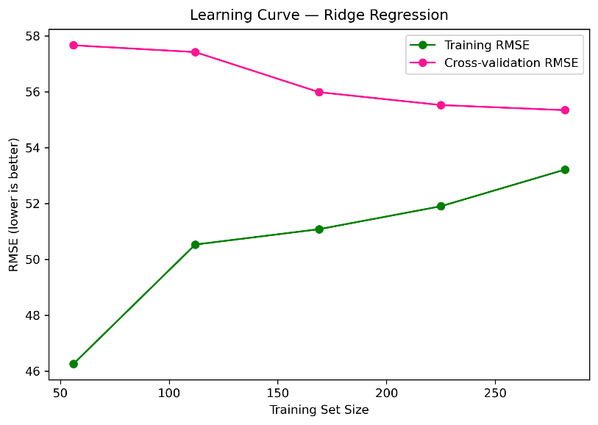
Figure 5. Ridge regression learning curve
Cross-validation RMSE falls as training size increases, while training RMSE rises. The gap narrows, but validation error remains higher, suggesting more representative data or better features may help.
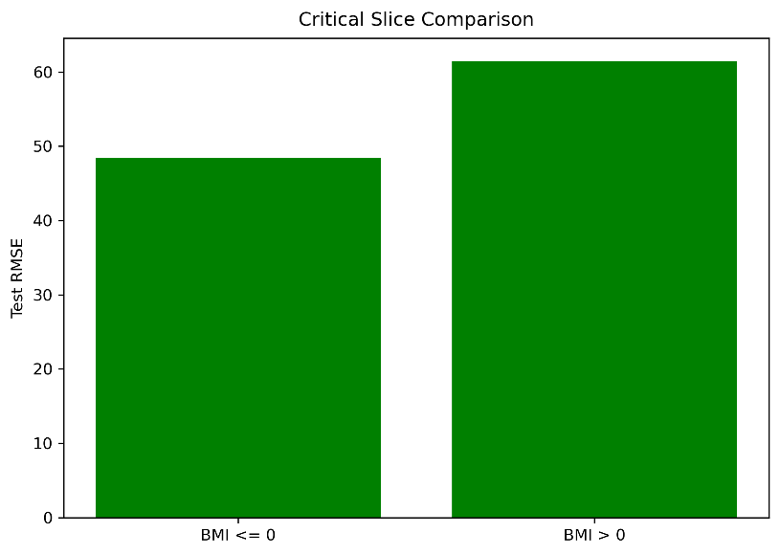
Figure 6. Critical-slice comparison by centered BMI
The BMI-above-mean slice has higher RMSE (about 61.47) than the at-or-below-mean slice (about 48.42). This shows that average performance can hide subgroup differences.

Model Comparison and Final Assessment
Ridge has the lowest RMSE (53.777) and highest R² (0.454), but its gain over ordinary linear regression is tiny. Both regression models outperform the naive-mean baseline on this fixed test set.
Table 1. Model comparison on the frozen test set
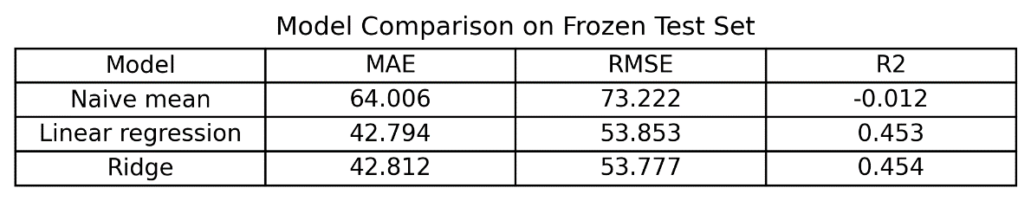
Breusch–Pagan p=0.0345 indicates evidence of non-constant residual variance. Shapiro–Wilk p=0.6398 does not provide evidence against normality; Cook’s-distance screening identifies cases for inspection.
Figure 8. Regression diagnostics summary
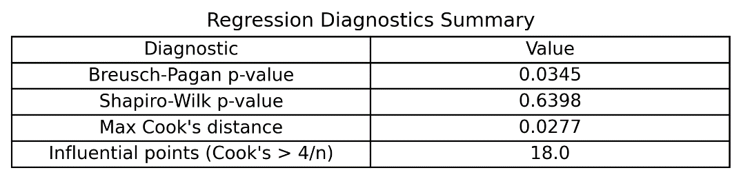

Conclusion
Ridge is the best of the three models by RMSE and R², but the gain over linear regression is negligible. The Breusch–Pagan result suggests non-constant variance; influential observations and higher error in the BMI-above-mean slice should be reviewed. Before deployment, conduct external validation, examine error cases and subgroup performance, and document limitations. Observed associations should not be interpreted as causal effects.
Reproducibility: retain the executable notebook, frozen dataset, environment/dependency record, and result CSV files with this report.

